**Sentinel: Swarming UAVs with Computer Vision for Firefighters**

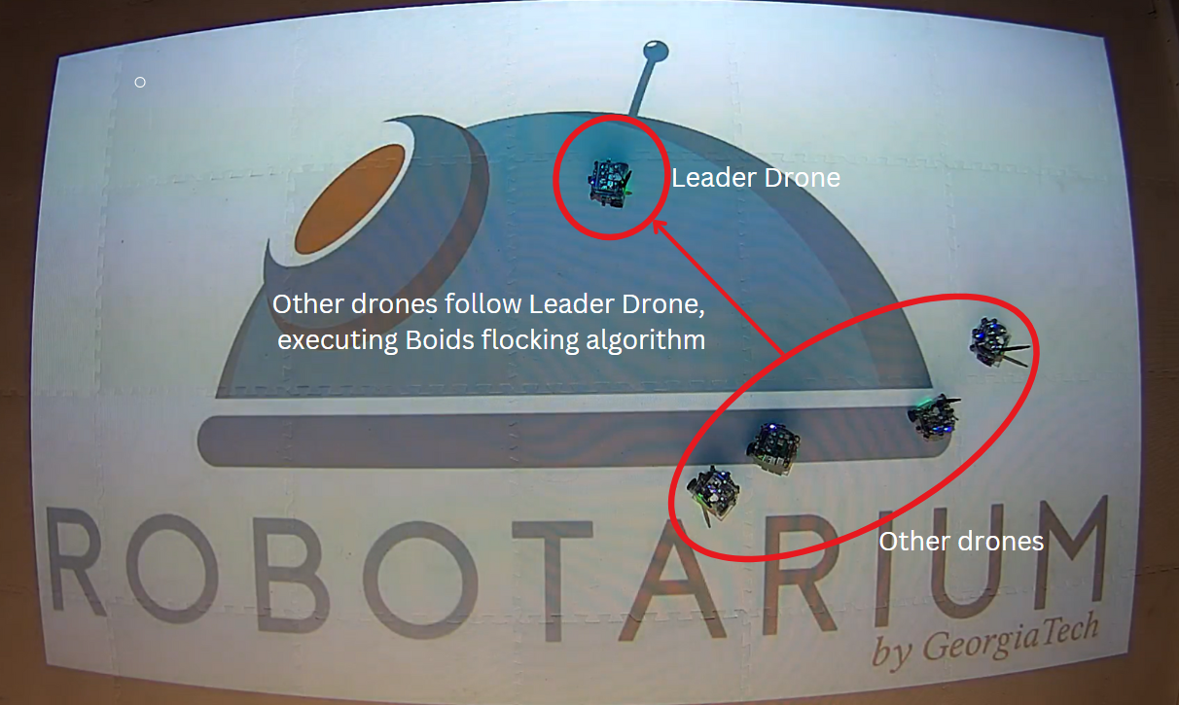

**Abstract**

This research presents Sentinel: Swarming UAVs with Computer Vision and other sensor for Firefighters, an autonomous drone system aimed at reducing risks for first responders. Loss of a firefighter is gut-wrenching as they race to save others, with firefighting as one of the most dangerous professions. Each year, nearly 100 firefighter fatalities and 70,000 injuries occur. By leveraging multi-agent UAV coordination with computer vision and other sensors like thermal image/gas/CO2, Sentinel can autonomously detect fire hazards, optimize firefighter ingress and egress, and provide strategic deployment recommendations.

This work is based on Boids flocking with Leader-Follower algorithm, simulation-based swarm coordination and fire detection, and finally to real-world validation at Georgia Tech's Robotarium, where autonomous coordination algorithms were tested on physical robots. Future development focuses on real-world deployment, further improving the system with advanced sensor integration and multi-agent coordination.

Code**:** https://github.com/zacharyzhu-ai/Swarming-UAV

Reference**:** Robust Online Epistemic Replanning of Multi-Robot Missions – UVA.

**Introduction**

On February 16, 2024, Trevor Brown, a fellow firefighter, tragically lost his life in a propane explosion while responding to an emergency in my community. His passing highlighted the urgent need for better situational awareness for first responders and drove me to create Sentinel: Swarming UAVs for Firefighters, an autonomous drone-based system designed to enhance firefighter safety by providing real-time hazard detection and response guidance before firefighters arrive on scene.

Sentinel uses multi-agent UAV coordination and computer vision to autonomously detect fire hazards, optimize routes for ingress and egress, and provide strategic recommendations for the deployment of fire engines, ladder trucks, and ambulances. What began as a simulation-based project has since progressed to real-world validation at Georgia Tech’s Robotarium, where the system's algorithms were tested on physical robots.

**Methodology**

**1. Simulation and Algorithm Development**

The initial phase of this project focused on simulating UAV swarm behavior using the Boids flocking algorithm. The drones follow the leader, mimicking natural flock behavior. This algorithm was implemented for autonomous swarm coordination, enabling the drones to move together and detect hazards in their environment.

**Key Achievements:**

* Implemented Boids flocking algorithm (drone simulation mimicking bird flocking behavior for autonomous swarm coordination).
* Ran fire detection simulations to demonstrate how UAVs can identify fire hazards and provide real-time feedback.

Image 1: Initial Fire Detection

Image 2: Closer Fire Detection

**2. Real-World Testing at Georgia Tech’s Robotarium**

Following the success of the simulations, Georgia Tech’s Robotarium provided a platform for testing multi-agent UAV control on real ground robots. The Boids algorithm was applied to swarm coordination, and computer vision (OpenCV) was integrated to detect fire hazards and evaluate ingress/egress points for first responders.



Image 3: Physical Testing at Robotarium

**3. Ready to take the flights!**

The Robotarium tests successfully demonstrated the foundational algorithm, albeit in a grounded robotics (unicycle) setting, and without obstacle/fire-simulation. Dr. Sean Wilson, Head of Robotarium, was gracious in offering potential next steps including their plan to launch Crazyflie 2.1 Nano Drone.

As a next step, I will begin flight testing with the Crazyflie 2.1 Nano Drone, further advancing Sentinel from ground-based testing to airborne deployment.

**Results and Real-World Application**

Before firefighters arrive on scene, Sentinel’s UAV swarm can launch autonomously, providing the following critical capabilities:

* Rooftop fire detection & hazardous zone identification
* Strategic positioning guidance for fire engines, ladder trucks, and ambulances
* Ingress and egress recommendations, offering safe entry and exit routes for firefighters

These capabilities aim to enhance firefighter safety by providing real-time, actionable intelligence about the fire scene.

**Next Steps and Future Research**

* “Add vectors to the Boids flocking algorithm to pull each agent toward the heat source.” —Dr. Wilson, Branch Chief of Robotics and Autonomous Systems, Georgia Tech Research Institute.
* Transition from simulation to physical flight tests on PX4/ArduPilot/Crazyflie.
* Implement explosion detection, risk assessment, and multi-sensor fusion for real-world deployment.
* Collaborate with interdisciplinary teams to further integrate AI, robotics, and economics to optimize the deployment of UAVs in emergency response scenarios.

**Conclusion**

Sentinel represents a step forward in enhancing first responder safety using autonomous UAV swarms. The transition from simulation to real-world testing at Georgia Tech marks an important milestone in the development of the system. Future work will focus on real-world deployment, integrating advanced sensors, and refining multi-agent coordination algorithms to improve the system’s capabilities.

I expect to have a fully operational prototype with the Crazyflie Nano Drone before freshman year. In parallel, I am working through Loudoun County Combined Fire & Rescue where I have been a volunteer firefighter, toward a full and functional Swarm of UAVs.